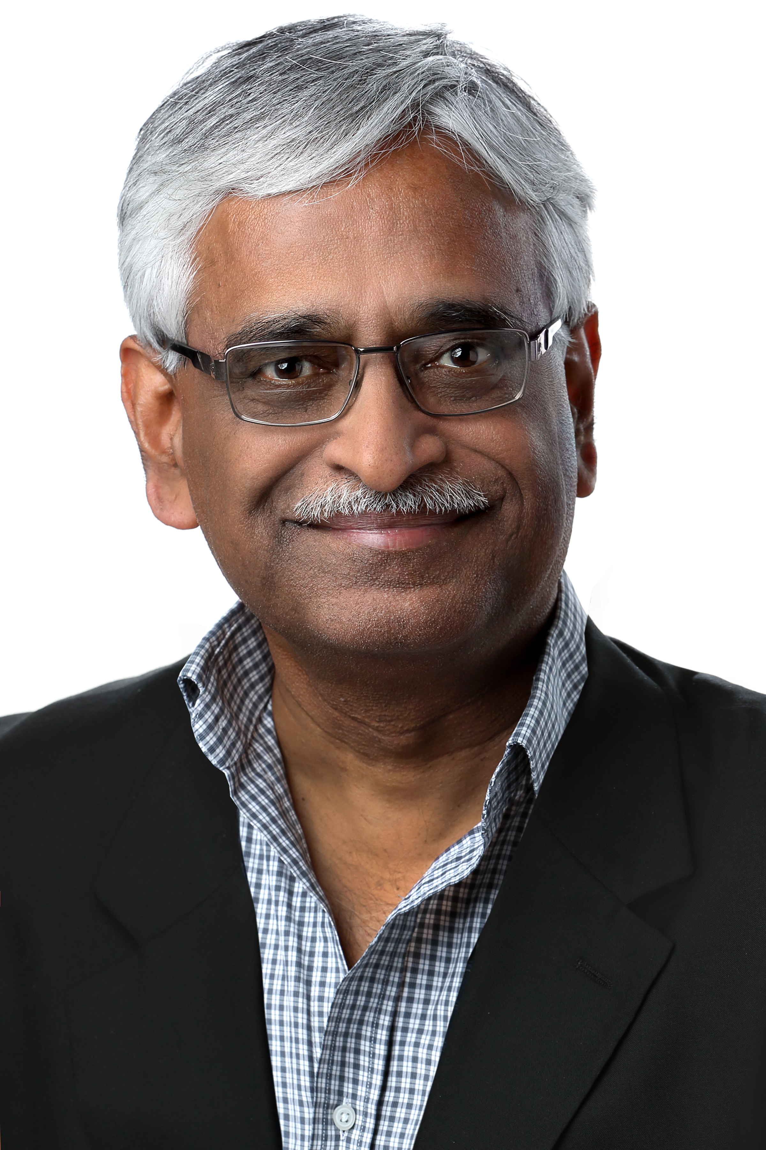Dr. C. Mohan’s Photo and Biodata
Distinguished Professor of Science (Hong Kong Baptist University, China)
Distinguished Visiting Professor (Tsinghua University, China)
Member, Board of Governors (Digital University Kerala, India)
Retired IBM Fellow (IBM Research, USA) & Former Shaw Visiting Professor (National Univ of Singapore) Former Visiting Researcher (Google, USA)
Short Form: Dr. C. Mohan is currently a Distinguished Professor of Science at Hong Kong Baptist University, a Distinguished Visiting Professor at Tsinghua University in China, and a member of the inaugural Board of Governors of Digital University Kerala in India. He retired in 2020 from being an IBM Fellow at the IBM Almaden Research Center in Silicon Valley. He was an IBM researcher for 38.5 years in the database, blockchain, AI and related areas, impacting numerous IBM and non-IBM products, the research and academic communities, and standards, especially with his invention of the well-known ARIES family of database locking and recovery algorithms, and the Presumed Abort distributed commit protocol. This IBM (1997-2020), ACM (2002-) and IEEE (2002-) Fellow has also served as the IBM India Chief Scientist (2006-2009). In addition to receiving the ACM SIGMOD Edgar F. Codd Innovations Award (1996), the VLDB 10 Year Best Paper Award (1999) and numerous IBM awards, Mohan was elected to the United States and Indian National Academies of Engineering (2009). This Distinguished Alumnus of IIT Madras (1977) received his PhD at the University of Texas at Austin (1981). He is an inventor of 50 patents. During the last many years, he focused on Data, Cloud, Blockchain and AI technologies (https://bit.ly/CMoTalks). During 2021, Mohan was the Shaw Visiting Professor at the National University of Singapore. Mohan has been on numerous conference and journal boards. During 2022, he was a consultant (Visiting Researcher) at Google. He was a Consultant to the Microsoft Data Team in 2020. Mohan is a frequent speaker in North America, Europe and Asia. He has given talks in 43 countries. More information can be found in the Wikipedia page at https://bit.ly/CMwIkP and his homepage at https://bit.ly/CMoDUK
Long Form: Dr. C. Mohan is currently a Distinguished Professor of Science at Hong Kong Baptist University, a Distinguished Visiting Professor at Tsinghua University in China, a member of the inaugural Board of Governors of Digital University Kerala, and an Advisor of the Kerala Blockchain Academy (KBA) and the Tamil Nadu e-Governance Agency (TNeGA) in India. He retired in June 2020 from being an IBM Fellow at the IBM Almaden Research Center in Silicon Valley. He joined IBM Research (San Jose, California) in 1981 where he worked until May 2006 on several topics in the areas of database, workflow, and transaction management. From June 2006, he worked as the IBM India Chief Scientist, based in Bangalore, with responsibilities that relate to serving as the executive technical leader of IBM India within and outside IBM. In February 2009, at the end of his India assignment, Mohan resumed his research activities at IBM Almaden. Mohan is the primary inventor of the well-known ARIES family of database recovery and concurrency control methods, and the industry-standard Presumed Abort commit protocol. He was named an IBM Fellow, IBM's highest technical position, in 1997 for being recognized worldwide as a leading innovator in transaction management. In 2009, he was elected to the United States National Academy of Engineering (NAE) and the Indian National Academy of Engineering (INAE). He received the 1996 ACM SIGMOD Edgar F. Codd Innovations Award in recognition of his innovative contributions to the development and use of database systems. In 2002, he was named an ACM Fellow and an IEEE Fellow. At the 1999 International Conference on Very Large Data Bases (VLDB), he was honored with the 10 Year Best Paper Award for the widespread commercial, academic and research impact of his ARIES work, which has been extensively covered in textbooks and university courses. From IBM, Mohan received 2 Corporate and 8 Outstanding Innovation/Technical Achievement Awards. He is an inventor on 50 patents. He was named an IBM Master Inventor in 1997. Mohan worked very closely with numerous IBM product and research groups, and his research results are implemented in numerous IBM and non-IBM prototypes and products like DB2, MQSeries, WebSphere, Informix, Cloudscape, Lotus Notes, Microsoft SQLServer, Sybase and System Z Parallel Sysplex. During the last many years, he focused on Blockchain, AI, Big Data and Cloud technologies (https://bit.ly/sigBcP, https://bit.ly/CMoTalks, https://bit.ly/CMgMDS). Since 2017, he has been an evangelist of permissioned blockchains and the myth buster of permissionless blockchains. During 1H2021, Mohan was the Shaw Visiting Professor at the National University of Singapore (NUS) where he taught a seminar course on distributed data and computing. In 2019, he became an Honorary Advisor to TNeGA of Chennai for its blockchain and other projects. In 2020, he joined the Advisory Board of KBA of India. Since 2016, he has been a Distinguished Visiting Professor of China’s prestigious Tsinghua University in Beijing. In 2023, he was named Distinguished Professor of Science of Hong Kong Baptist University. In 2021, he was inducted as a member of the inaugural Board of Governors of the new Indian university Digital University Kerala (DUK). Mohan launched his consulting career by becoming a Consultant to Microsoft's Data Team in October 2020. From March-December 2022, he was a non-employee consultant at Google with the title of Visiting Researcher. He has been on the advisory board of IEEE Spectrum and has been an editor of VLDB Journal, and the journal Distributed and Parallel Databases. In the past, he has been a member of the IBM Academy of Technology’s Leadership Team, IBM's Research Management Council, IBM's Technical Leadership Team, IBM India's Senior Leadership Team, the Bharti Technical Advisory Council, the Academic Senate of the International Institute of Information Technology in Bangalore, and the Steering Council of IBM's Software Group Architecture Board. Mohan received his PhD in computer science from the University of Texas at Austin in 1981. In 2003, he was named a Distinguished Alumnus of IIT Madras from which he received a B.Tech. in chemical engineering in 1977. Mohan is a frequent speaker in North America, Europe and Asia. He has given talks in 43 countries. He is highly active on social media and has a huge following. More information can be found in the Wikipedia page at https://bit.ly/CMwIkP and his homepage at https://bit.ly/CMoDUK.

